A guide for integration of AngelScript Compiler to MS Visual Studio 2005 and 2008 (probably 2003 as well).

- Run MSVS.
- Go to Tools -> External Tools…
- Press Add button.
- Type Title, Command, Arguments, Initial directory and flags like on Pic 1.
- Move Up line to top, press OK.

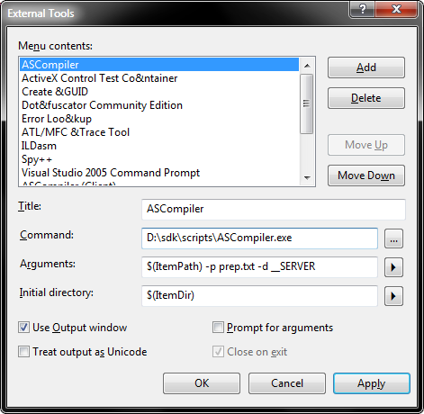
Pic 1

- Go to Tools -> Customize.
- Select Tools and drag and drop “External Command 1” to Build menu (Pic 2).
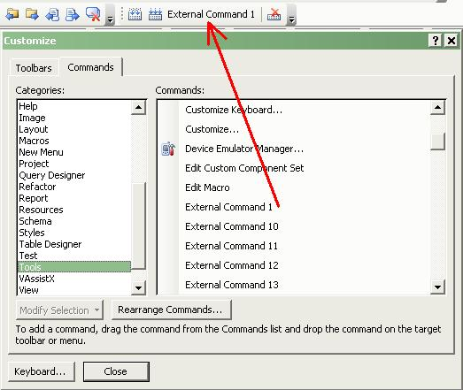
Pic 2
- Go to Tools -> Options -> Text editor -> File extension.
- Add “fos” extension and press Apply (Pic 3).

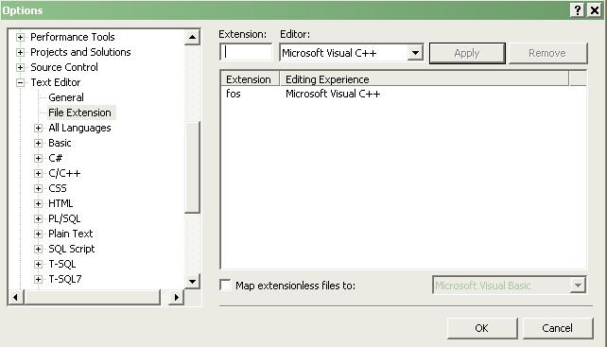
Pic 3

- Copy file usertype.dat to Program Files\Microsoft Visual Studio 8\Common7\IDE\.
- Restart IDE.
- [optional, recommended] Follow further instructions in Solution\Readme.txt.

